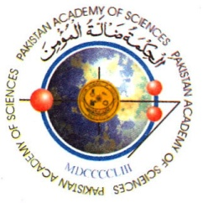 | PAKISTAN ACADEMY OF SCIENCES  3- Constitution Avenue, G-5/2, Islamabad, Ph: (92-51) 9204843  Email: sec.gen@paspk.org

Travel Grant

Name of the Fellow: ________________
Designation and Organization: ________________
Title of event (Conference, Symposia, Workshop etc.): ________________
Venue, date and duration: ________________
Organized by: ________________
Main theme of Conference: ________________
Nature of your Participation:
- Invited Speaker:
- Speaker:
- Participant to represent Pakistan:
- Member of some Committee:
- Visit to establish a collaborative research project:
- Any other Capacity:
Title of paper to be presented: ________________
Amount requested from PAS: ________________
Whether the following are attached:
- Copy of Invitation/acceptance Letter:
- Abstract of paper to be presented:
- Invoice for Purchase of Ticket:

*Request should be sent to PAS on the prescribed proforma along with relevant information, at least 6 weeks before the event date.

