Article Title
Author Name¹, Author Name^{2*}, and Author Name^{1,2}
¹Department One, Institution One, City One, Country One, Email One
²Department Two, Institution Two, City Two, Country Two, Email Two

Abstract: Must be self-explanatory, stating the rationale, objective(s), methodology, main results, and conclusions of the study. Abbreviations, if used, must be defined on the first mention in the Abstract as well as in the main text. Abstract of review articles may have a variable format. (250 words)
Keywords: Posuere, Pulvinar exposure, Vivamus enzyme, Pellentesque.

- INTRODUCTION

Sample text inserted for illustration [1]. Replace with article text, including headings where appropriate. Figures and tables can be single- or double-column width as appropriate [2]. During the production process they will be placed at the top or bottom of columns, after they are first cited in the text [3].

At, vulputate vitae, pretium mattis, nunc. Mauris eget neque at sem venenatis eleifend. Ut nonummy. Fusce aliquet pede non pede.
1.1 Subsection Heading
Suspendisse dapibus lorem pellentesque magna. Integer nulla. Donec blandit feugiat ligula. Donec hendrerit, felis et imperdiet euismod, purus ipsum pretium metus, in lacinia nulla nisl eget sapien [4]. Donec ut est in lectus consequat consequat. Etiam eget dui. Aliquam erat volutpat. Sed at lorem in nunc porta tristique.
Proin nec augue. Quisque aliquam tempor magna. Pellentesque habitant morbi tristique senectus et netus et malesuada fames ac turpis egestas. Nunc ac magna. Maecenas odio dolor, vulputate vel, auctor ac, accumsan id, felis. Pellentesque cursus sagittis felis. Pellentesque porttitor, velit
Lorem ipsum dolor sit amet, consectetuer adipiscing elit. Maecenas porttitor congue massa. Fusce posuere, magna sed pulvinar ultricies, purus lectus malesuada libero, sit amet commodo magna eros quis urna. Nunc viverra imperdiet enim. Fusce est. Vivamus a tellus. Pellentesque habitant morbi tristique senectus et netus et malesuada fames ac turpis egestas. Proin pharetra nonummy pede.

Vivamus a mi. Morbi neque. Aliquam erat volutpat. Integer ultrices lobortis eros. Pellentesque habitant morbi tristique senectus et netus et malesuada fames ac turpis egestas. Proin semper, ante vitae sollicitudin posuere, metus quam iaculis nibh, vitae scelerisque nunc massa eget pede. Sed velit urna, interdum vel, ultricies vel, faucibus at, quam. Donec elit est, consectetuer eget, consequat quis, tempus quis, wisi.

    - Subsubsection Heading
Pellentesque habitant morbi tristique senectus et netus Pellentesque habitant morbi tristique senectus et netus os [5]. Pellentesque habitant morbi tristique senectus et netus commode. Cum Pellentesque habitant morbi tristique senectus et netus
Etiam at ligula et tellus ullamcorper ultrices. In fermentum, lorem non cursus porttitor, diam urna accumsan lacus, sed interdum wisi nibh nec nisl. Ut tincidunt volutpat urna. Mauris eleifend nulla eget mauris. Sed cursus quam id felis. Curabitur posuere quam vel nibh. Cras dapibus dapibus nisl. Vestibulum quis dolor a felis congue vehicula. Maecenas pede purus, tristique ac, tempus eget, egestas quis, mauris. Curabitur non eros. Nullam hendrerit bibendum justo.
- MATERIALS AND METHODS
Suspendisse dapibus lorem pellentesque magna. Integer nulla. Donec blandit feugiat ligula [6]. Donec hendrerit, felis et imperdiet euismod, purus ipsum pretium metus, in lacinia nulla nisl eget sapien. Donec ut est in lectus consequat consequat. Etiam eget dui. Aliquam erat volutpat. Sed at lorem in nunc porta tristique.

Proin nec augue. Quisque aliquam tempor magna. Pellentesque habitant morbi tristique senectus et netus et. Lorem ipsum dolor sit amet, consectetuer adipiscing elit. Maecenas porttitor congue massa. Fusce posuere, magna sed pulvinar ultricies, purus lectus malesuada Lorem ipsum dolor sit amet, consectetuer adipiscing elit. Lorem ipsum dolor sit amet, consectetuer adipiscing elit. Maecenas porttitor congue massa. Fusce posuere, magna sed pulvinar ultricies,.
Lorem ipsum dolor sit amet, consectetuer adipiscing elit. Maecenas porttitor congue massa. Fusce posuere, magna sed pulvinar ultricies, (Table 1) lectus malesuada Lorem ipsum dolor sit amet, consectetuer adipiscing elit. Maecenas porttitor congue massa. Fusce sed pulvinar ultricies, purus lectus posuere, magna sed pulvinar ultricies, purus lectus (Fig. 1).

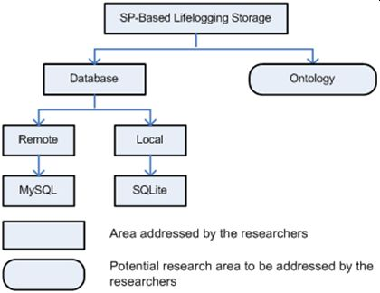

Fig 1. Pictures Description title

- RESULTS AND DISCUSSIONS
Lorem ipsum dolor sit amet, consectetuer adipiscing elit. Maecenas porttitor congue massa. Fusce posuere, magna sed pulvinar ultricies, purus lectus malesuada Lorem ipsum dolor sit amet, consectetuer adipiscing elit [7]. Maecenas porttitor congue massa. Fusce posuere, magna sed pulvinar ultricies, purus lectus as shown in Fig. 2.

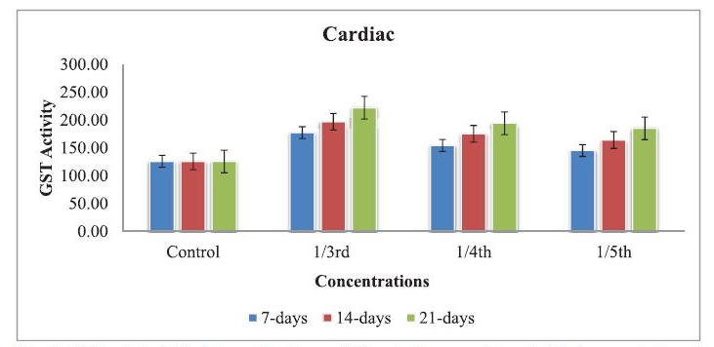

Fig 2. Pictures Description title

Fig 2. Pictures Description title

Table 1. Applications of accident analysis techniques in different industries

S. No | Methods | Applications | References
1 | FMEA | Space industry, Chemical industry, Thermal plant, Paper mill ,Nuclear | [2, 19-22]
2 | FMECA | Aerospace industry, Railway industry, Aviation industry, Food industry | [3, 23-25]
3 | FMEA | Space industry, Chemical industry, Thermal plant, Paper mill ,Nuclear | [2, 19-22]
4 | FMECA | Aerospace industry, Railway industry, Aviation industry, Food industry | [3, 23-25]
5 | FMECA | Aerospace industry, Railway industry, Aviation industry, Food industry | [3, 23-25]

4. CONCLUSIONS
Lorem ipsum dolor sit amet, consectetuer adipiscing elit. Maecenas porttitor congue massa. Fusce posuere, magna sed pulvinar ultricies, purus lectus malesuada Lorem ipsum dolor sit amet, consectetuer adipiscing elit. Maecenas porttitor congue massa. Fusce posuere, magna sed pulvinar ultricies, purus lectus.
5. ACKNOWLEDGEMENTS
Lorem ipsum dolor sit amet, consectetuer adipiscing elit. Maecenas porttitor congue massa. Fusce posuere, magna sed pulvinar ultricies, purus lectus malesuada Lorem ipsum dolor sit amet, consectetuer adipiscing elit. Maecenas porttitor congue massa. Fusce posuere, magna sed pulvinar ultricies, purus lectus.
6. REFERENCES
- Golding., J. Paulsson., S.M. Zawilski, and E.C. Cox. Real time kinetics of gene activity in individual bacteria. Cell 123: 1025–1036 (2005).
- W. Bialek, and S. Setayeshgar. Cooperative sensitivity and noise in biochemical signaling. Physical Review Letters 100: 258–263 (2008).
- R. K. Robert, and C.R.L.Thompson. Forming patterns in development without morphogen gradients: differentiation and sorting. Cold Spring Harbor Perspectives in Biology 1(6) (2009).
- D. Fravel. Commercialization and implementation of biocontrol. Annual Reviews of Phytopathology 43: 337-359 (2005).
- W.R. Luellen. Fine-Tuning Your Writing. Wise Owl Publishing Company, Madison, WI, USA (2001).
- U. Alon, and D.N. Wegner (Ed.). An Introduction to Systems Biology: Design Principles of Biological Circuits.Chapman & Hall/CRC, Boca Raton, FL, USA (2006).
- M. D. Sobsey & F. K. Pfaender. Evaluation of the H2S method for Detection of Fecal Contamination of Drinking Water, Report WHO/SDE/WSH/02.08, Water Sanitation and Health Programme, WHO, Geneva, Switzerland (2002).
- M.S. Sarnthein, and J.D. Stanford. Basal sauropodomorpha: historical and recent phylogenetic developments. In: The Northern North Atlantic: A Changing Environment. P.R. Schafer, & W. Schluter (Ed.), Springer, Berlin, Germany, p. 365–410 (2000).
- J.E. Smolen, and L.A. Boxer. Functions of Europhiles. In: Hematology, 4th ed. W.J. Williams., E. Butler and M.A. Litchman (Ed.), McGraw Hill, New York, USA, p. 103–101 (1991).
- L. Branston. SENSPOL: Sensors for Monitoring Water Pollution from Contaminated Land, Landfills and Sediment (2000). http://www.cranfield.ac.uk/biotech/senspol/ (accessed 22 July 2005)

