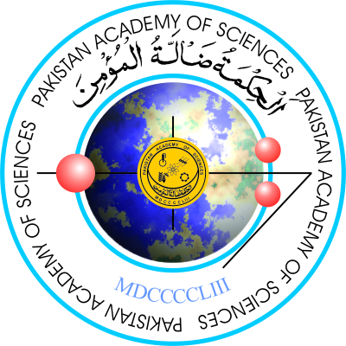
Information to be provided by Nominees for PAS Gold Medals and Prizes

(It may be noted that the onus of authenticity of the data provided in the form will lie on the nominee himself. Provision of wrong data will render the nomination invalid)
S. No. | Parameter
 | Age (as per CNIC)
PhD
(Major Field, Name and country of the university)
Cumulative Impact Factor
(Attach Complete List and copy of first page of each paper)
Citations (of publications in Impact Factor Journals)
(Attach ISI Web of Knowledge graph and Google Scholar)
H-Index:
(Attach ISI Web of Knowledge graph and Google Scholar)
Fellowship of Scientific Societies:
- International
- National
(Attach certificate)
PhDs Produced as Major Supervisor:
(Attach copy of degree award notification in each case)
Patents/Varieties/Technology/Product/Gene sequences developed
(Attach copies of certificates)
Books Authored:
- International Publishers
- Local Publishers
(Attach title page of each book)
Book Chapters Authored:
International Publishers only
(Attach copy of title page of each book)
Research Grants (≥ Rs. 0.5 Million) Secured as P.I.:
- International
- National
(Title and cost of grant, and approval letter from funding agency)
Note: Other than Parent Organization
 | Civil Awards:
Awards:
- International
- National
(Copy of the Certificate)

Name of Applicant: ____________________________________________________________
Designation and Address: ______________________________________________________
______________________________________________________________________________
______________________________________________________________________________
Email: ________________________________ Cell No: _______________________________
Signature of Applicant: _________________________________________________________

* Additional sheets may be used, if required.

